**Project Goal**

The goal of the project is to develop a Web based booking platform, primarily for barber shops, but in a long run could be adopted by nails saloons or spas. Customers can schedule and cancel their appointment at the chosen barber shop. Barber shops can register and advertise their services, provider schedules for each of their employees. Thanks to that they can shorten the waiting time in their saloons. Additionally, if this goal is finished in a timely manner it will be extended to work on mobile based platform.

**Approach**

The application will have to main users the Customers and the Shops providing the services. Both users will have access to their personal profile and in return will be able to view other profiles in the network. The application will include user log in, register, log out options to have access to the platform. A database to store users’ information. Shops will be able to add employees to their profiles so users can choose from them. And these employees will also be able to add their hours so users have a better understanding of available hours. Both categories of users will be able to edit their profiles to make changes and update information. Users should be able to search for shops they are interested in.

**Progress**

Authentication Process for Customers and Service Providers have been finished.

Users can register as customers or shops. Shops can register employees. Employee with manager’s privilages can register schedules for employees.

Few test have been written for backend models, however not sufficient and have to be catch up on, which is the goal for the next 4 days long sprint.

Application has been deployed on heroku servers for testing purposes in a neutral environment.

**Future work**

The main goal for next 4 days is to create a mutual environment using Docker or similar tool to make development more portable and synchronization easier.

Later, the front end will be worked on for a more exciting user experience. Write more test for the user registration to handle different scenarios. Add more features to the profile pages to display more information to users.

**Contribution:**

Mod_auth (authentication module and database models definitions): Daniel Bis

Signup functions together with Christian Pileggi (Pair Programming)

mod_provider (scheduling working hours by managers): Daniel Bis

__init__ and run files: Daniel Bis

HTML Templates: Daniel Bis

test.py : Abraham D’mitri Joseph and Daniel Bis (pair programming)

Heroku deployment: Daniel Bis

Readme: Daniel Bis

Wiki: Ajayi Oluwatobi

Report: Ajayi Oluwatobi, Daniel Bis

**Git Log:**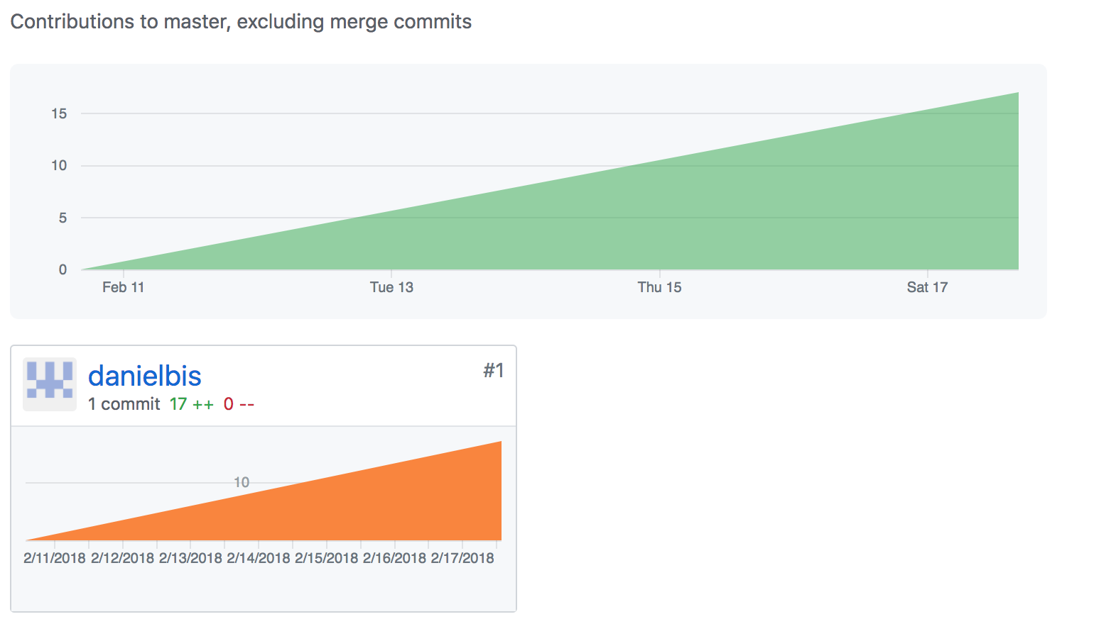

**Heroku Log:**

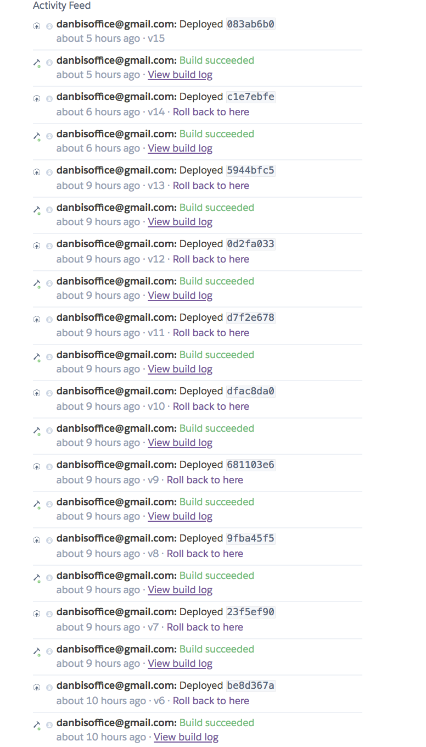

Wiki Page Update

